Why AI? Why Integrate AI into Your Projects?

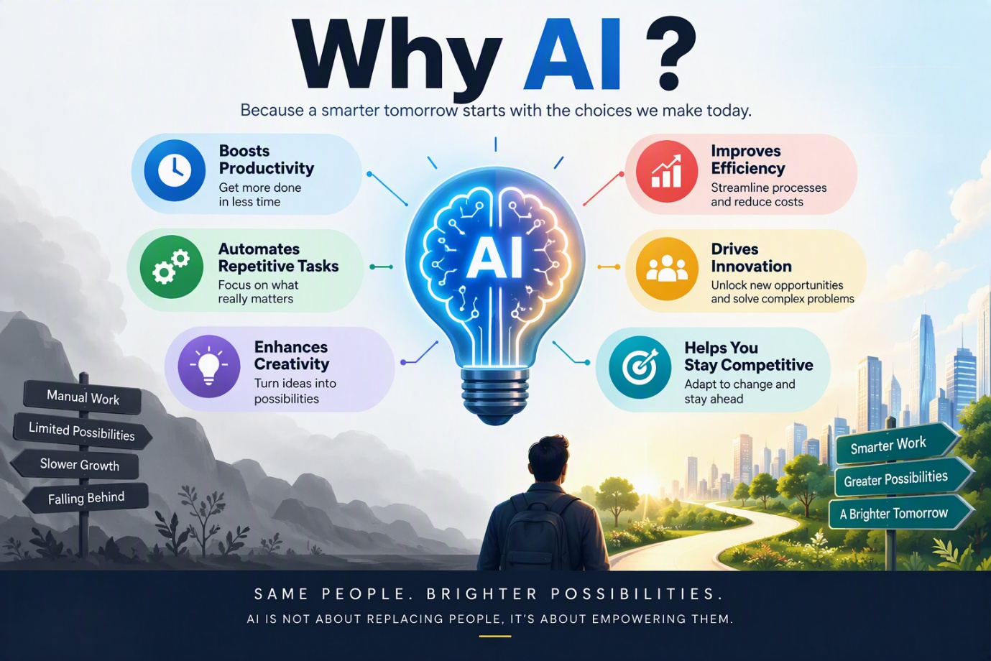
These days, AI is everywhere. While not everyone may be asking the question, many people still wonder: Why AI? Why should I integrate AI into my projects?
The answer is simple: AI has the potential to transform the way we work and live. When integrated effectively into both professional and personal activities, AI can significantly improve productivity, efficiency, and creativity. It helps automate repetitive tasks, streamline workflows, and unlock new opportunities for innovation and growth.
AI adoption is rapidly increasing across industries and is expected to reshape the future of work over the coming years. Organizations and individuals who embrace AI today are better positioned to stay ahead of the curve, adapt to evolving market demands, and remain competitive in a fast-changing world.
How Can You Start Adopting AI?
Here are some practical tips to help you get started:
- Identify your key challenges and priorities. Focus on areas where AI can deliver the greatest value and impact.
- Use AI strategically. Leverage AI tools to automate routine tasks, enhance creativity, and boost productivity.
- Learn the art of prompting. Writing clear and effective prompts helps you get better, more accurate results from AI tools.
- Start with free or freemium tools. Explore available options before investing in premium solutions when your needs grow.
- Optimize one area at a time. Whether it's productivity, organization, communication, or creativity, focus on gradual improvements rather than trying to change everything at once.
- Stay informed. Follow AI experts, thought leaders, and industry trends to learn best practices and keep up with the latest advancements.
Final Thought
AI is not about replacing people; it's about empowering them. By adopting AI thoughtfully and strategically, you can work smarter, innovate faster, and create greater value in both your professional and personal life.

